The Online Voucher Application Portal will be opened from May 26 to June 2, 2019 to accept applications from incoming Grade 11 students in SY 2019-2020.

Online application is very strongly encouraged.
For online applications, submit the filled out form and scanned copy of the complete documents to the Online Voucher Application Portal (OVAP) on or before June 2. OVAP accounts may be created until May 31 only.
Online Application Procedures:
1. Access the Online Voucher Application Portal (OVAP) at https:ovap.peac.org.ph and follow the instructions to create an account. A valid and working email address is needed to create an account. Wait for the confirmation email to be sent to the submitted email address.
2. Upon receipt of the confirmation email, click on the link provided to access the OVAP as a registered user.
3. Complete the electronic Voucher Application Form (VAF-1)
4. Scan or take a picture and upload the following:

      - Recent 2×2 colored ID photo
      - Parent Consent Form
      - Certification of financial assistance received (issued by the school), if applicable
      - Proof of financial means of the parents, guardian, or the person who is helping send the student to school as shown in the table below:
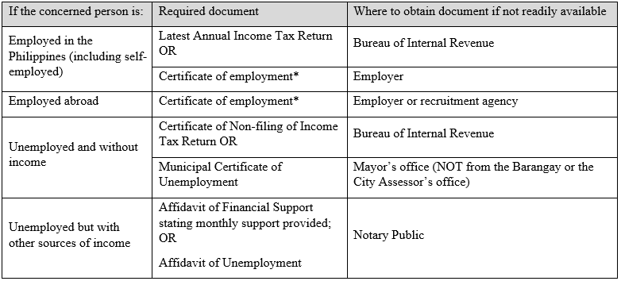*The certificate of employment should state the person’s occupation and gross monthly income. For employees, gross monthly income refers to the gross monthly wages or salaries before taxes and other deductions. It includes basic pay, overtime pay, commissions, tips, allowances and one-twelfth of annual bonuses. For all others, it refers to the average monthly earnings from their business, trade, profession, investments and/or pensions.
5. Submit the application when the VAF-1 and the required documents are complete. OVAP automatically confirms receipt of application.
For manual applications, mail or personally submit the filled out Voucher Application Form (VAF-1) and complete requirements to the PEAC National Secretariat, 5th Floor Salamin Building, 197 Salcedo Street, Makati City 1229 on or before May 31.
For inquiries, please call the PEAC National Secretariat at (02) 840-6000‬ local 130-132 and 840-6007‬ or send an email to shs.vms@peac.org.ph‬. ‬‬‬‬‬‬‬‬‬‬‬‬‬‬‬
Template – Parent Consent Form
Template – Municipal Certification of Unemployment
Template – Affidavit of Unemployment
[DO] Annex 1 Voucher Applicant Form (VAF-1)
[DO] Annex 2 Privacy Notice
[DO] Annex 3 Certificate of Financial Assistance
[DO] Guidelines on the Application for the SHS VP 2019-2020

